Resources Used to Maintain and Develop Code/Application and How to Freely Install These Tools.

Resources with Version Numbers:

* Notepad++ v7.5.8 (x32)
* Notepad++ FTP (NppFTP) v0.26.3 (x32) – Only works with x32 Npp
* MySQL Workbench v8.0.12 (x64)
* GearHost N/A – Web Application

How to freely login to GearHost

1. Navigate to <https://www.gearhost.com/>

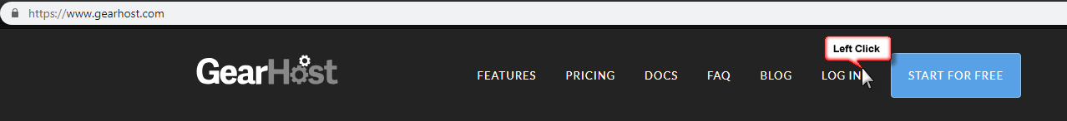

1. Login using the credentials below or you can also find them in the credentials text file in the docs section of the repository

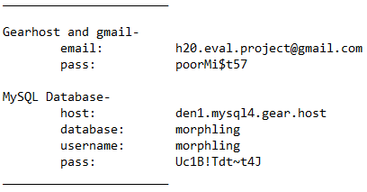

1. Below you can see the Cloud Site

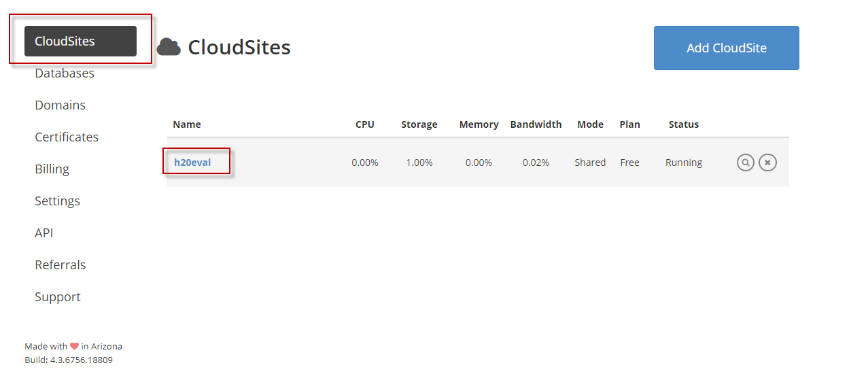

1. Clicking on Databases brings you to the database of the Cloud Site

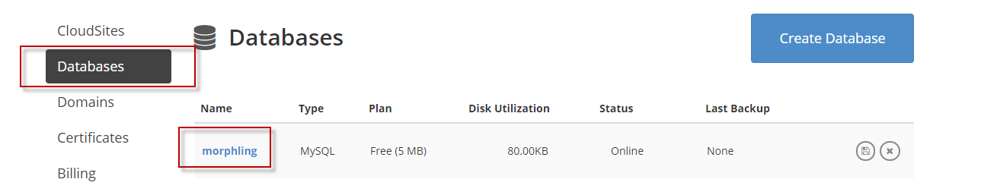

How to freely install Notepad++

1. Navigate to <https://notepad-plus-plus.org/>

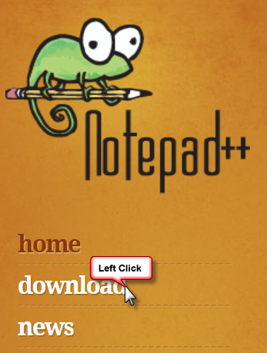

1. Select the proper install.

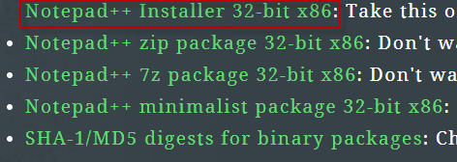

How to freely install Notepad++ FTP

1. Navigate to <https://sourceforge.net/projects/nppftp/>
2. Click Download

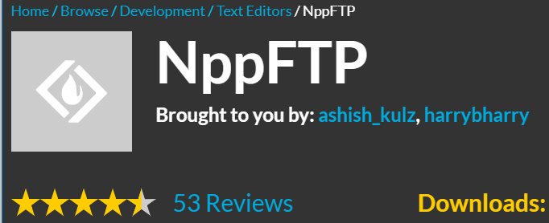

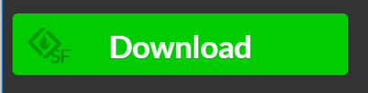

To use NppFTP: Copy the DLL file to the following directory:

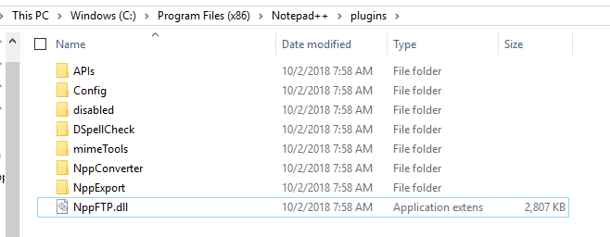

Connecting to the Database using the FTP in NPP:



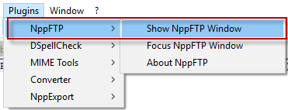

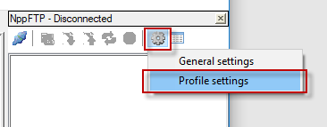

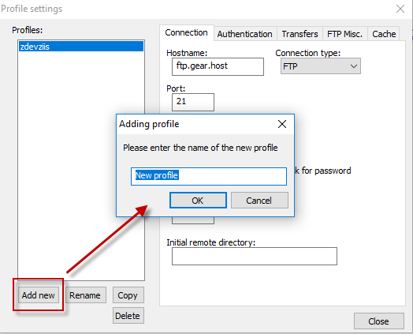

Fill out the form by using the information found on GearHost below:

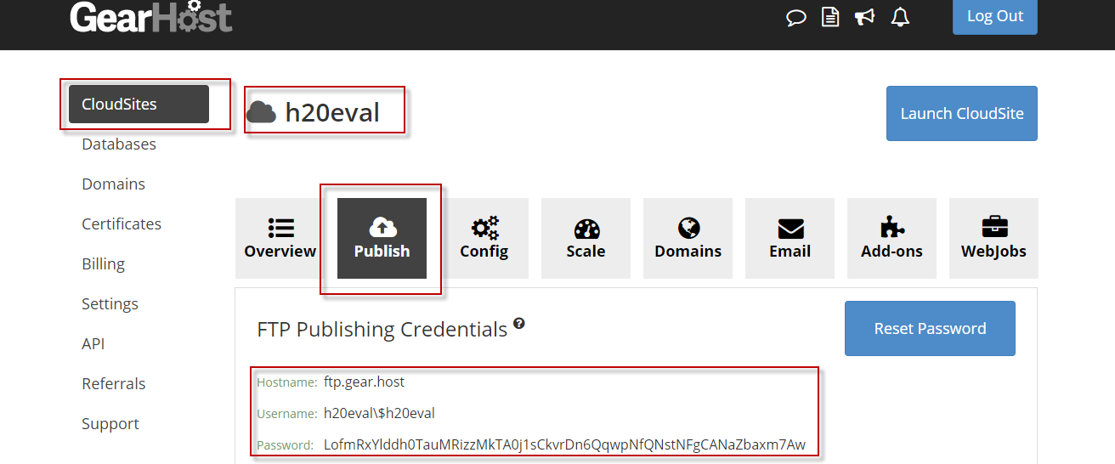

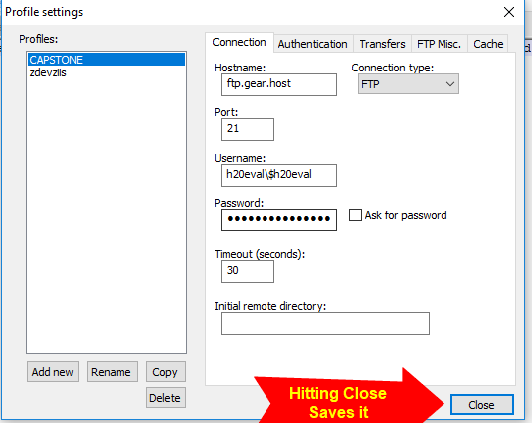

How to freely install MySQL Workbench

1. Navigate to <https://dev.mysql.com/downloads/>
2. Find the proper version and click download.

